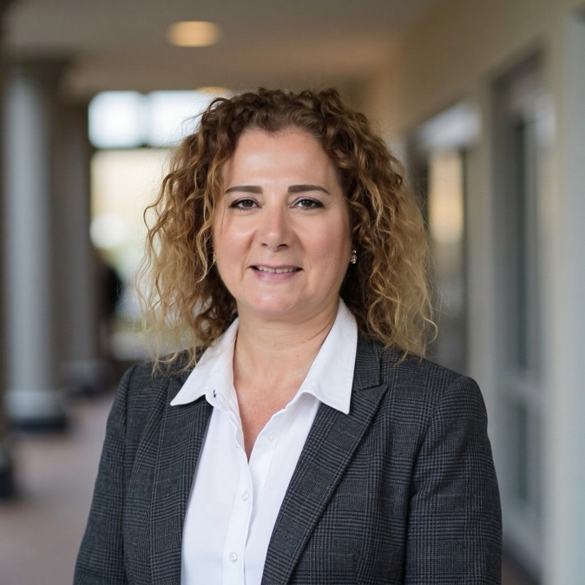
I operate at the intersection of strategy and execution—helping biotech organizations translate complex scientific and corporate priorities into systems that drive results.
I began my career in physician practice operations, where I developed a foundational understanding that outcomes are determined not just by strategy, but by the strength of the underlying systems. I later spent over a decade at Genentech in non-clinical development and eight years at Amgen, leading program management and partnering closely with Clinical Development leadership.
Most recently, I served as Chief of Staff to CMO-level executives at Prothena and Bolt Biotherapeutics, where I built the operational infrastructure required to scale clinical-stage organizations—establishing governance, improving cross-functional alignment, and enabling disciplined portfolio execution. This work resulted in reclaiming approximately 30% of leadership capacity.
With a scientific background, I engage deeply in clinical and R&D discussions while designing the governance frameworks, operating models, and decision structures that translate complexity into execution.
Through The RightHand Strategy, I partner with biotech leadership teams to build and scale R&D strategic operations—bringing clarity to prioritization, alignment across functions, and structure to support growth.

